Introduction:
These 9 stations are designed to provide you with practical strategies for teaching FMS effectively to our students. At each station, you will explore the specific skill through targeted techniques, instructional strategies, and adaptations that address the diverse and unique needs of our learners.
Objective:
By the end of this activity, you will:
- Gain a deeper understanding of how to teach fundamental movement skills.
- Learn to adapt skills, strategies, and equipment to meet your students’ abilities.
- Be equipped with practical tools and ideas to implement in your PE lessons.
Key Reminder:
You are the most important factor in your students' learning. Your understanding of their needs, strengths, and challenges will determine how effectively these skills are taught. Be prepared to adapt the movements, teaching strategies, and equipment to maximize learning outcomes. Continuous review and assessment of your students' progress will be necessary to guide and refine your teaching approach. Progress matters more than perfection.
Instructions:
- Spend 5 minutes at each station.
- Actively try out the movement or activity presented, using the equipment provided.
- Use the checklist on this document to assess your understanding and record any reflections or observations.
Map of Stations:
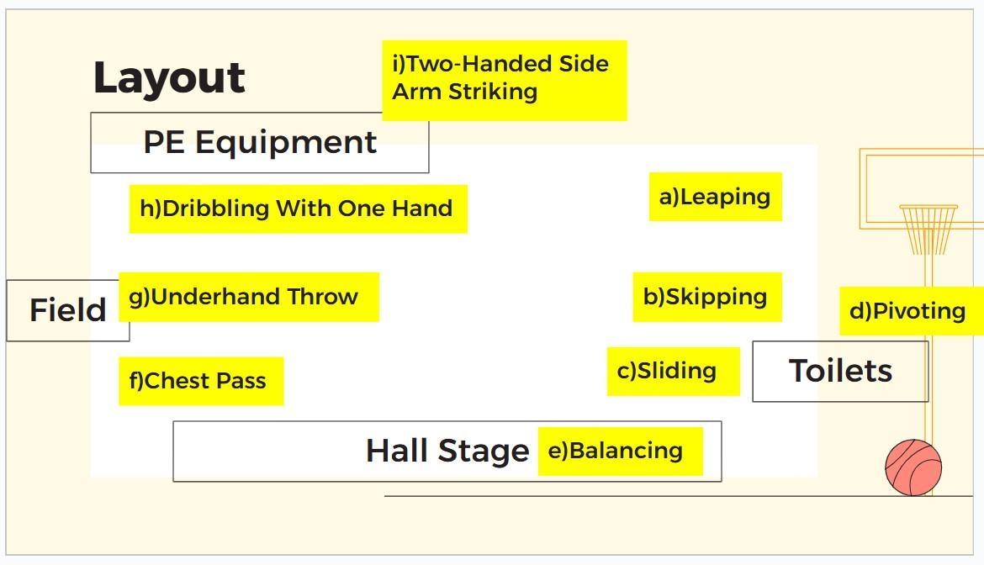

Checklist for Understanding
 | Skill | Do you know how to demonstrate this skill correctly? | Can you break this skill into clear, simple phases for teaching? | Can you identify 1 adaptation to make this skill accessible for students of varying abilities? | Can you suggest an activity that effectively incorporates this skill for your students?
A | Leaping
B | Skipping
C | Sliding
D | Pivoting
E | Balancing
F | Chest Pass
G | Underhand Throw
H | Dribbling with One Hand
I | Two-Handed Side Arm Striking

What is Leaping?
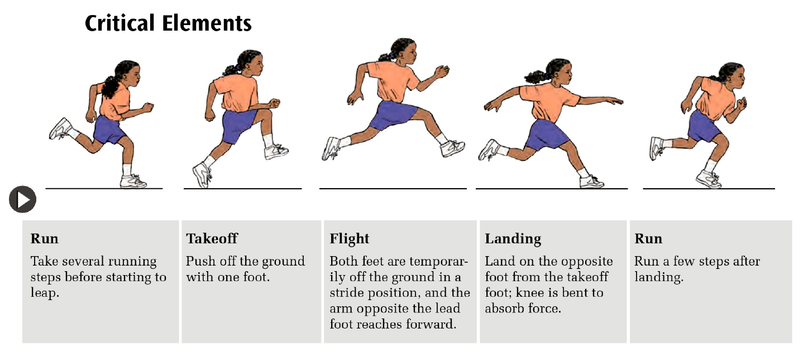
Leaping is a locomotor movement where students take off from one foot and land on the opposite foot. It is an exaggerated running motion and a foundational movement that helps develop coordination, balance, and strength. Leaping is used in sports (e.g., basketball, hurdles), leisure activities (e.g., skipping games), and daily life tasks (e.g., stepping over obstacles).

Technical Explanation of Leaping
Leaping involves four key phases:
- Preparation (Run):
  - Take small running steps to gain momentum.
  - Arms swing naturally to generate balance and rhythm.
- Takeoff:
  - Push off one foot forcefully.
  - Swing the opposite knee and arms forward to propel the body
upward and forward.
  - Verbal Cue: “Push and swing!”
- Flight:
  - Both feet leave the ground.
  - The body fully extends as students “fly” forward.
  - Verbal Cue: “Stretch out like a superhero!”
- Landing:
  - Land softly on the opposite foot with the knee bent to absorb impact.
  - Maintain balance with arms spread slightly.
  - Verbal Cue: “Land softly like a cat.”

Pedagogical Strategies for Teaching Leaping
- Explicit Instruction (I Do, We Do, You Do):
  - I Do: Demonstrate the leap while clearly describing each phase. Use simple terms like “Push, swing, fly, and land.”
  - We Do: Guide students step-by-step, using prompts and visual cues.
  - You Do: Allow students to practice independently with verbal feedback.
- Visual Aids and Task Cards:
  - Use pictures, task cards, or diagrams to illustrate the leaping phases.
  - Example: Show visuals of “Takeoff,” “Flight,” and “Landing” on separate cards.
- Task Analysis:
  - Break the movement into smaller steps:

    - Stand tall → Take small steps → Push off one foot → Swing arms → Land softly.

- Adaptations (TREE Framework):
  - Teaching Methods: Use verbal prompts, physical guidance, or video modelling.
  - Rules: Allow smaller takeoffs or shorter distances.
  - Equipment: Place colored cones or markers to indicate takeoff and landing spots.
  - Environment: Reduce distractions, and ensure a clear, safe space for leaping.
Student Profile | Adaptation
Students with low motor skills | Stationary takeoff with visual markers (e.g., “Step here → Land there”).
Students with ASD (sensory challenges) | Use colored markers and clear verbal cues. Minimize loud noises or distractions.
Students with high energy or confidence | Increase takeoff distance or introduce small hurdles to leap over.

Suggested Activities for Leaping
- Stationary Takeoff and Land:
  - From a standing position, push off one foot and land softly on the opposite foot.
  - Focus on swinging the arms and balancing on landing.
- Walk, Leap, and Land:
  - Students take walking steps, then leap over a line or marker.
  - Increase the distance gradually as students gain confidence.
- Obstacle Leap:
  - Use cones, hoops, or mats as “puddles” or “hurdles” for students to leap over.
  - Encourage students to shout “Leap!” as they jump to make it engaging.
- Leaping Challenge (Modified Game):
  - Students leap from one marker to another, following a visual trail.
  - Use prompts: “Push off, swing high, and land softly!”

Key Teaching Points for Leaping
- Use simple, clear instructions and visual aids.
- Demonstrate the leap step-by-step, focusing on takeoff, flight, and landing.
- Provide positive feedback: “Well done for swinging your arms!”
- Adapt the activity based on students' abilities and needs.

Why is Leaping Important?
Leaping develops coordination, balance, and strength, which are essential for overcoming obstacles in daily life. For SEN students, leaping improves confidence and physical ability to step over puddles, curbs, or uneven surfaces while moving safely. It also helps them enjoy hobbies like playing simple games, jumping in obstacle courses, or participating in sports like modified athletics.
What is Skipping?
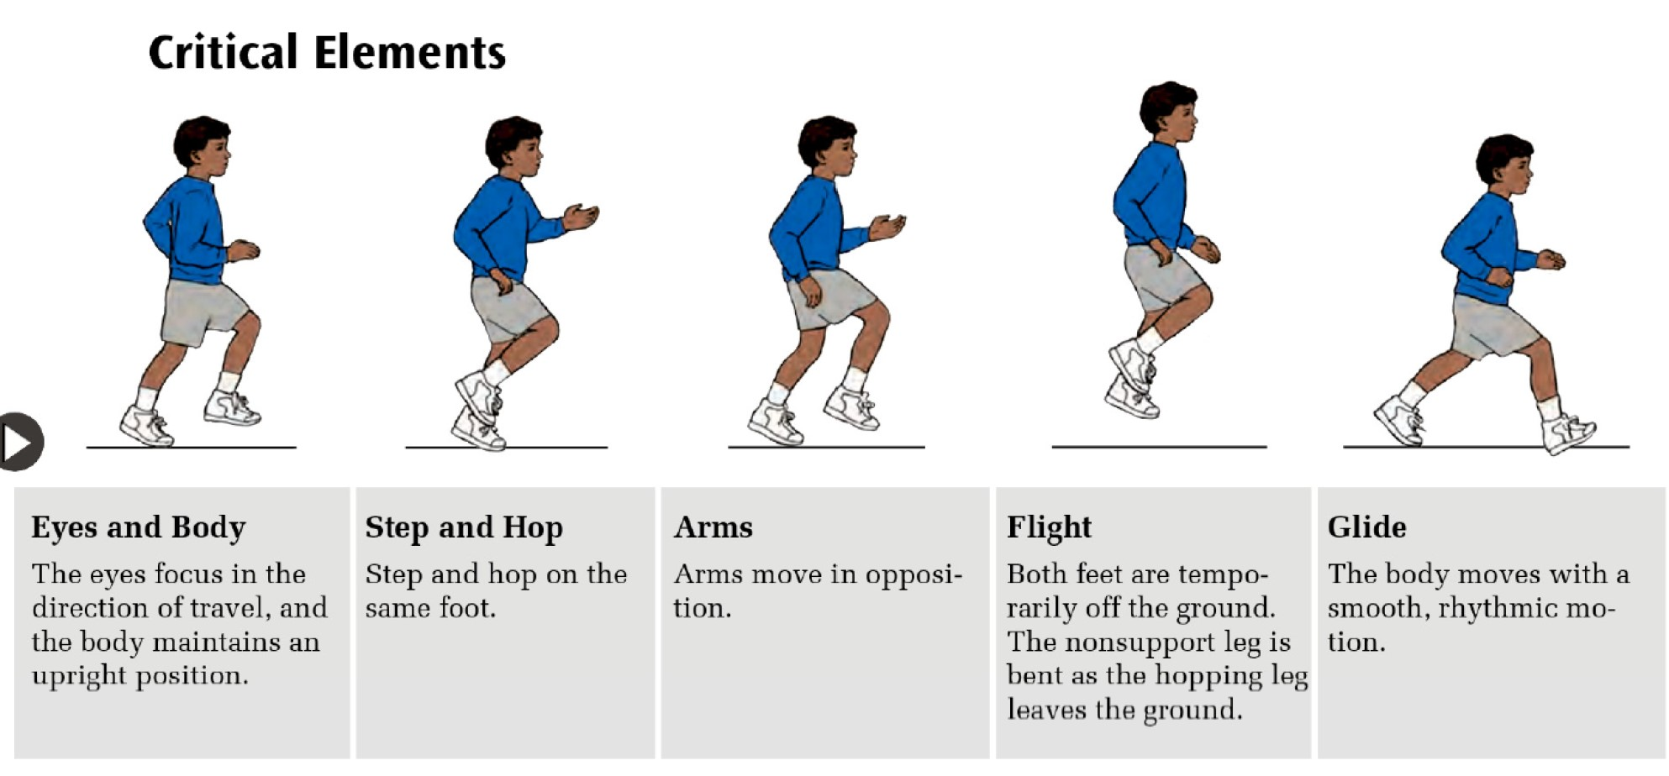
Skipping is a locomotor skill that combines a step and a hop on the same foot, performed rhythmically and with a smooth, flowing motion. It develops coordination, rhythm, balance, and motor control, which are essential for sports, dance, and daily tasks.

Technical Explanation of Skipping
Skipping involves five key elements:
- Eyes and Body:
  - Eyes focus on the direction of travel.
  - Body remains upright with a slight forward lean.
- Step and Hop:
  - Step forward on one foot, then hop on the same foot.
  - Repeat the movement with the other foot.
- Arms:
  - Arms swing in opposition to the legs for balance and momentum.
  - Cue: “Step with the left, swing the right arm!”
- Flight:
  - Both feet leave the ground during the hop.
  - The nonsupport leg bends as the hopping leg pushes off.
- Glide:
  - The body moves smoothly and rhythmically in a forward motion.

Pedagogical Strategies for Teaching Skipping
- Explicit Instruction (I Do, We Do, You Do):
  - I Do: Demonstrate skipping step-by-step with cues like “Step-hop, step-hop.”
  - We Do: Guide students in small groups or pairs. Use physical guidance if necessary.
  - You Do: Allow independent practice while providing constructive feedback.
- Visual Aids and Demonstrations:
  - Use pictures, task cards, or videos to illustrate the skipping sequence.
  - Show videos of students or adults performing skipping as models.
- Task Analysis:
  - Break skipping into smaller, manageable phases:
Step forward → Hop → Land softly → Repeat.
- Adaptations (TREE Framework):
  - Teaching Methods: Use rhythmic cues, visuals, and simple games to make learning engaging.
  - Rules: Start with stepping only; progress to step-hop when ready.
  - Equipment: Use markers or hoops for pathways and soft surfaces for landing.

  - Environment: Create clear pathways and minimize distractions for students with sensory challenges.
Student Profile | Adaptation
Students with low motor skills | Practice stepping forward and hopping separately before combining the two movements.
Students with ASD (sensory challenges) | Use rhythmic cues (e.g., clapping, “Step-hop”) and visuals to maintain focus.
Students with high energy or confidence | Incorporate skipping in games (e.g., obstacle skipping or skipping to music).

Suggested Activities for Teaching Skipping
- Step-and-Hop Practice:
  - Start with walking steps: Step → Pause → Hop.
  - Gradually reduce pauses to build rhythm and coordination.
- Skipping with Rhythmic Cues:
  - Use clapping, tambourines, or verbal cues like “Step-hop, step-hop” to teach rhythm.
- Skipping Pathway:
  - Create trails using markers or hoops for students to follow.
  - Simplify: Step through markers first, then introduce hopping.
- Skipping Games:
  - Follow the Leader: Teachers or peers demonstrate skipping patterns, and students follow.
  - Beanbag Skipping: Students skip to pick up beanbags placed along a pathway.
  - Skipping to Music: Play a song with a steady beat to encourage rhythmic skipping.
- Building Up to Skipping:
  - Practice hopping on one foot to develop balance and coordination.
  - Use small hurdles or markers to introduce the step-hop motion.
  - Start with galloping, then transition to skipping to establish rhythm.

Key Teaching Points for Skipping
- Use simple, consistent instructions and rhythmic cues like “Step-hop, step-hop.”
- Demonstrate skipping step-by-step, focusing on the step, hop, and arm swing phases.
- Adapt the activity using visuals, simplified movements, or physical prompts.
- Provide positive reinforcement to celebrate progress and build confidence.
- Make learning fun by incorporating music, games, and engaging visuals.

Why is Skipping Important?
Skipping helps SEN students develop rhythm, balance, and coordination, skills that are useful for moving confidently and safely. It builds leg strength and cardiovascular fitness, which are important for climbing stairs, crossing uneven ground, or dancing to music as a fun, expressive hobby. Skipping can also be part of playful activities during free time, encouraging social interaction and active recreation..

What is Sliding?
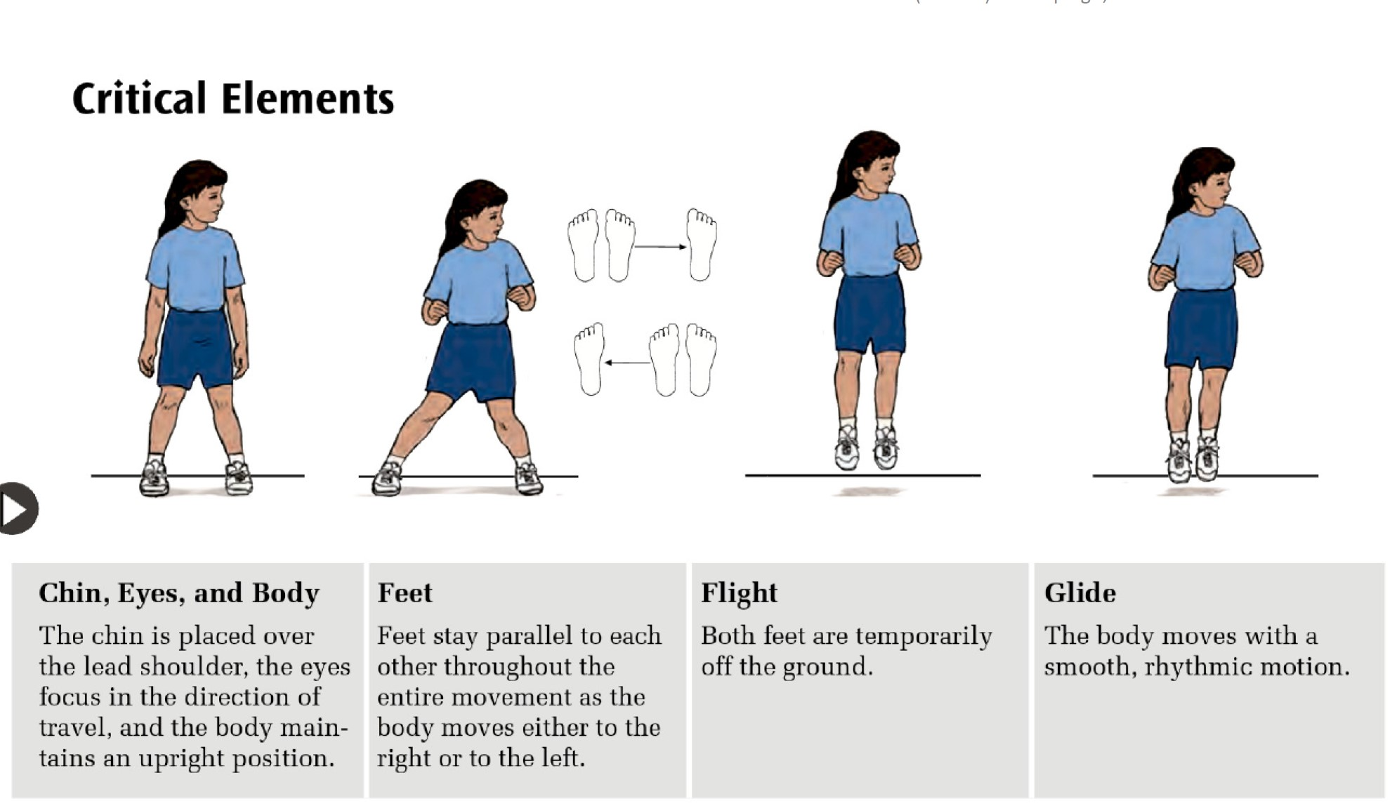
Sliding is a locomotor skill that involves moving sideways in a step-close pattern. One foot leads the action, followed by the other foot quickly closing to meet it. This skill develops rhythm, balance, and coordination and is essential for activities that require quick lateral movements, such as sports, games, and real-life tasks.

Technical Explanation of Sliding
Sliding involves four key elements:
- Chin, Eyes, and Body
  - Chin is placed over the lead shoulder.
  - Eyes focus in the direction of movement.
  - Body stays upright with a slight lean forward.
- Feet
  - Feet remain parallel throughout the movement.
  - Lead foot steps sideways while the trailing foot quickly “closes the gap.”
- Flight
  - Both feet temporarily leave the ground as the trailing foot moves toward the lead foot.
- Glide
  - The movement is smooth and rhythmical, with consistent step-close rhythm: “step-close, step-close.”

Pedagogical Strategies for Teaching Sliding
- Explicit Instruction (I Do, We Do, You Do):
  - I Do: Demonstrate the sliding step with clear verbal cues: “Step, close. Step, close.”
  - We Do: Practice the movement together in pairs or small groups. Use physical guidance if needed.
  - You Do: Allow students to try sliding independently while giving positive feedback.
- Visual Aids and Demonstrations:
  - Use pictures or task cards to illustrate each phase of sliding.
  - Show a video or live demonstration of sliding in slow motion to reinforce understanding.
- Task Analysis:
Break the movement into smaller, manageable phases:
  - Step with lead foot → Close with trailing foot → Maintain balance → Repeat rhythmically.
- Adaptations (TREE Framework):
  - Teaching Methods: Use rhythmic cues like “Step-close, step-close” and physical demonstrations.

  - Rules: Start with slow, controlled movements and progress to quicker steps.
  - Equipment: Use markers on the ground to show the pathway for sliding.
  - Environment: Create clear, open spaces with minimal distractions to support focus and safety.
Student Profile | Adaptation
Students with low motor skills | Use visual markers for the step-close motion; start with slower and smaller steps.
Students with ASD (sensory needs) | Provide rhythmic verbal cues (“Step-close”) and use task cards for clear visuals.
Students with high energy | Add challenges like sliding over longer distances or incorporating games for engagement.

Suggested Activities for Teaching Sliding
- Step-Close Practice:
  - Start with slow steps: “Step-close, pause.”
  - Gradually reduce pauses to build rhythm and smooth motion.
- Sliding Pathway:
  - Place markers or cones in a straight line. Students slide along the line.
  - Simplify: Use shorter distances and larger markers for students who need support.
- Mirror Sliding:
  - In pairs, one student leads the slide movement while the other mirrors.
  - Encourage switching roles after a few rounds.
- Sliding Challenge:
  - Students slide to pick up beanbags or other small objects placed along a pathway.
- Sliding to Music:
  - Play music with a steady beat and have students slide to the rhythm.

Key Teaching Points for Sliding
- Use simple, consistent instructions like “Step-close, step-close” to guide students.
- Demonstrate sliding step-by-step, focusing on the step, close, and smooth rhythm.
- Adapt the activity for different abilities using visuals, smaller distances, and rhythmic cues.
- Provide positive reinforcement to build confidence and celebrate effort.
- Make the activity engaging with games, music, or visuals to encourage participation.

Why is Sliding Important?
Sliding improves spatial awareness, balance, and coordination by teaching controlled sideways movements. For SEN students, it develops physical skills that can assist in side-stepping around furniture or navigating crowded spaces safely. Sliding movements can also be incorporated into activities like dance routines, recreational games, or sports drills that focus on lateral movement.

What is Pivoting?
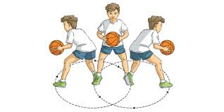
Pivoting is a non-locomotor skill where a student rotates their body around a fixed point, typically one foot, while the other foot steps in a new direction. It involves balance, coordination, and control. Pivoting is crucial for sports like basketball, netball, and dance, as well as daily movements requiring a change in direction.

Technical Explanation of Pivoting
Pivoting involves four key elements:
- Body and Eyes
  - Eyes look in the direction of the pivot.
  - Body remains upright and controlled with the head aligned over the shoulders.
- Pivot Foot
  - One foot stays planted on the ground as the pivot point.
  - The weight is placed on the ball of the pivot foot for balance.
- Step and Rotate
  - The non-pivot foot steps in the desired direction.
  - The body rotates smoothly around the pivot foot.
- Arms for Balance
  - Arms extend naturally to assist with balance and control during the movement.
Movement | Definition | Example
Pivot | Rotating around a fixed point (usually one foot), while the other foot steps. | Pivoting to pass a ball in basketball.
Turn | The whole body moves to face a new direction; the base of support may move. | Turning to face a new partner in dance.
Twist | One body part turns opposite to another body part or a fixed base. | Twisting the torso while seated to look back.

Pedagogical Strategies for Teaching Pivoting
- Explicit Instruction (I Do, We Do, You Do)
  - I Do: Demonstrate pivoting clearly, using cues like “Plant, step, turn!”
  - We Do: Guide students through pivoting in pairs. Use physical prompts if needed.
  - You Do: Allow students to practice independently while providing feedback.
- Visual Aids and Demonstrations
  - Use task cards or videos to demonstrate pivoting phases.
  - Highlight the fixed pivot foot and smooth body rotation.
- Task Analysis
  - Break pivoting into smaller steps:

    - Plant one foot as the pivot point.
    - Step with the other foot in the new direction.
    - Rotate the body smoothly.
    - Maintain balance with arms extended.
- Adaptations (TREE Framework)
  - Teaching Methods: Use visual cues, verbal prompts like “Plant and turn,” and physical demonstrations.
  - Rules: Simplify by allowing a smaller pivot angle (e.g., 45 degrees) before progressing to 90 degrees.
  - Equipment: Use floor markers or hoops to indicate the pivot point and direction.
  - Environment: Create clear, distraction-free spaces for practice.
Student Profile | Adaptation
Students with low motor skills | Practice smaller pivot angles (e.g., 45 degrees) before progressing to 90
Students with ASD (sensory challenges) | Use clear visual markers on the floor and verbal cues for guidance.
Students with high energy | Incorporate pivoting into fast-paced games like passing a ball.

Suggested Activities for Teaching Pivoting
- Pivot Around a Marker
  - Place a cone or marker on the floor. Students practice planting one foot next to the marker and pivoting around it while keeping balance.
- Ball Passing Pivot
  - In pairs, students pivot to pass a ball to a partner. Focus on using a planted pivot foot and smooth body rotation.
- Pivot and Turn Relay
  - Students take turns running to a marker, planting their pivot foot, and rotating to return in the opposite direction.
- Mirror the Pivot
  - Teachers demonstrate a pivot movement while students mimic the action.
- Pivoting in Games
  - Incorporate pivoting into games such as basketball drills, netball passing, or dance

Key Teaching Points for Pivoting
- Use simple, clear instructions like “Plant, step, turn” to guide the movement.
- Demonstrate pivoting step-by-step, focusing on the pivot foot, smooth body rotation, and balance.
- Adapt the activity for students' abilities by starting with smaller angles or add floor markers.
- Reinforce balance and control, reminding students to keep their weight on the ball of the pivot foot.
- Make learning fun by incorporating pivoting into games, challenges, or rhythmic activities.

Why is Pivoting Important?
Pivoting teaches balance, coordination, and body awareness while turning efficiently on the spot. For SEN students, this skill is especially useful for reorienting themselves quickly in small spaces, such as turning to face someone while holding an object or navigating a classroom or home environment. Pivoting can also improve participation in games, dance, or other hobbies requiring directional changes.

What is Balance?
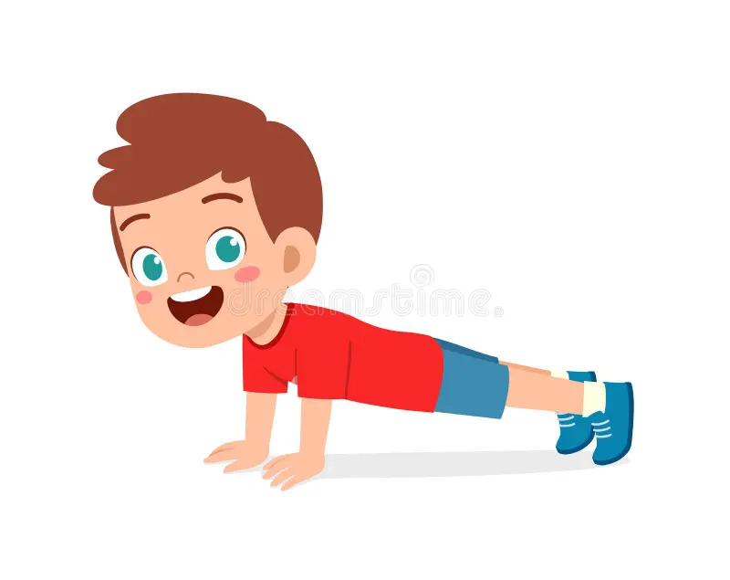
Balance is the ability to hold a position still while staying stable. It builds control, strength, and coordination, helping students in daily living skills (e.g., standing still, sitting upright) and recreational activities (e.g., playing games or cycling).

Technical Explanation of Balance.

Types of Balances
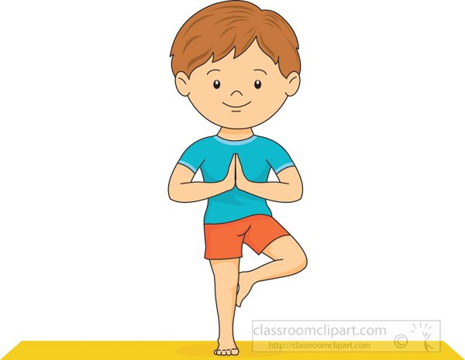
- Point Balances:
  - Small body parts in contact with the ground.
    - One-Point: Balancing on one foot.
    - Two-Point: Balancing on two feet or hands (e.g., plank).
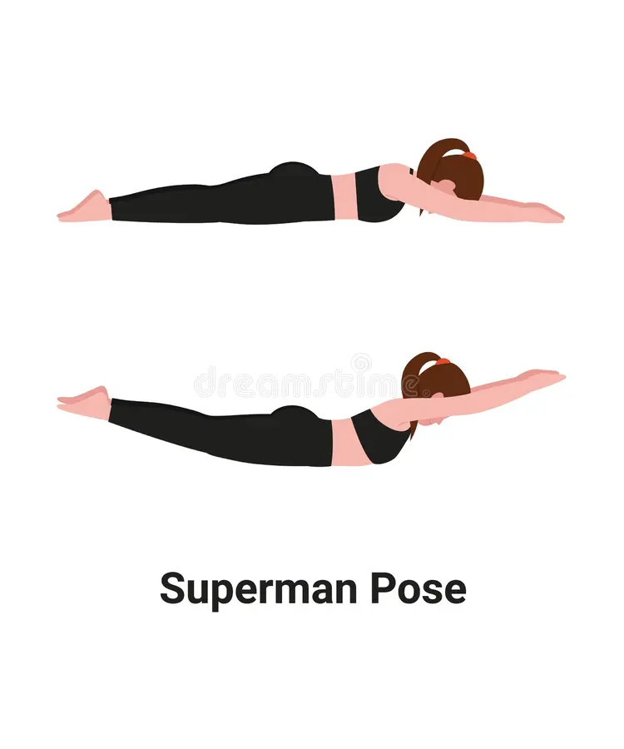
    - Three-Point: Two hands and one foot.
    - Four-Point: Both hands and feet.
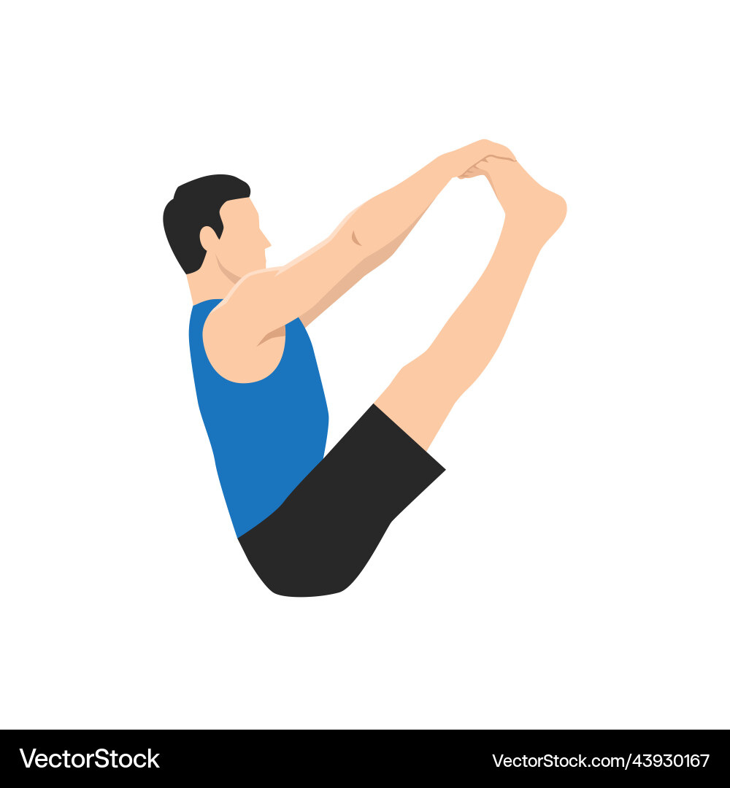
- Surface Balances:
  - Larger areas of contact for stability.
    - Stomach: Superman pose.
    - Back: Dead bug position.
    - Seated: V-sit position.

Pedagogical Strategies for Teaching Balance
- Explicit Instruction (I Do, We Do, You Do):
  - I Do: Demonstrate the balance step-by-step. Use simple cues like “Stand tall and still” or “Lift one leg and freeze.”
  - We Do: Guide students to practice in pairs or small groups. Provide physical or verbal prompts.
  - You Do: Allow independent practice and provide constructive feedback.
- Visual Aids and Demonstrations:
  - Use pictures, videos, or visual schedules to show correct body positions for different balances.
- Task Analysis:
  - Break the skill into smaller steps:
    - Find a stable base.
    - Shift body weight slowly.
    - Hold the position still for a few seconds.
    - Return to the starting position.
- Adaptations (TREE Framework):
  - Teaching Methods: Use fun cues like “Freeze like a statue” or “Superman pose.”

  - Rules: Start with larger contact points (e.g., two feet), then progress to smaller points (e.g., one foot).
  - Equipment: Use mats, balance beams, or markers for safe practice.
  - Environment: Provide a quiet, clear space to minimize distractions.
Student Profile | Adaptation
Students with low motor skills | Start with two or four-point balances (e.g., both feet and hands).
Students with ASD (sensory needs) | Use visual prompts (e.g., pictures or task cards) and verbal cues for focus.
Students with high energy or confidence | Introduce one-point balance challenges or timed balance games.

Suggested Activities for Teaching Balance
- One-Point Balance:
  - Balance on one foot with arms out. Simplify with wall or partner support.
- Surface Balance Challenge:
  - Stomach Balance: Lift arms and legs (Superman).
  - Back Balance: Arms and legs lifted in a “dead bug” pose.
- Balancing Pathway:
  - Balance on one foot or hold a position at markers along a path.
- Statue Freeze Game:
  - Play music; students freeze in a balance position when it stops.
- Partner Balances:
  - Students hold hands and balance together (e.g., one foot lifted).

Key Teaching Points for Balance
- Use simple instructions like “Freeze,” “Hold still,” or “Balance like a statue.”
- Demonstrate balance positions step-by-step and provide visual examples.
- Start with surface balances for greater stability, then progress to smaller points of contact (e.g., one foot).
- Encourage students to focus on a fixed point for balance (e.g., a spot on the floor).
- Provide positive reinforcement for effort and progress (e.g., “Good job holding still!”).

Why is Balance Important?
Balance helps students develop stability, control, and body awareness, which are crucial for daily living skills and hobbies. For example:
- Daily Living Skills: Standing still while brushing teeth, sitting upright at a desk, or stepping into the shower.
- Hobbies and Play: Balancing while cycling, playing hopscotch, performing simple yoga poses, or engaging in dance.
By mastering balance, students build confidence, strength, and coordination to participate in everyday tasks and activities safely and effectively.

What is a Chest Pass?
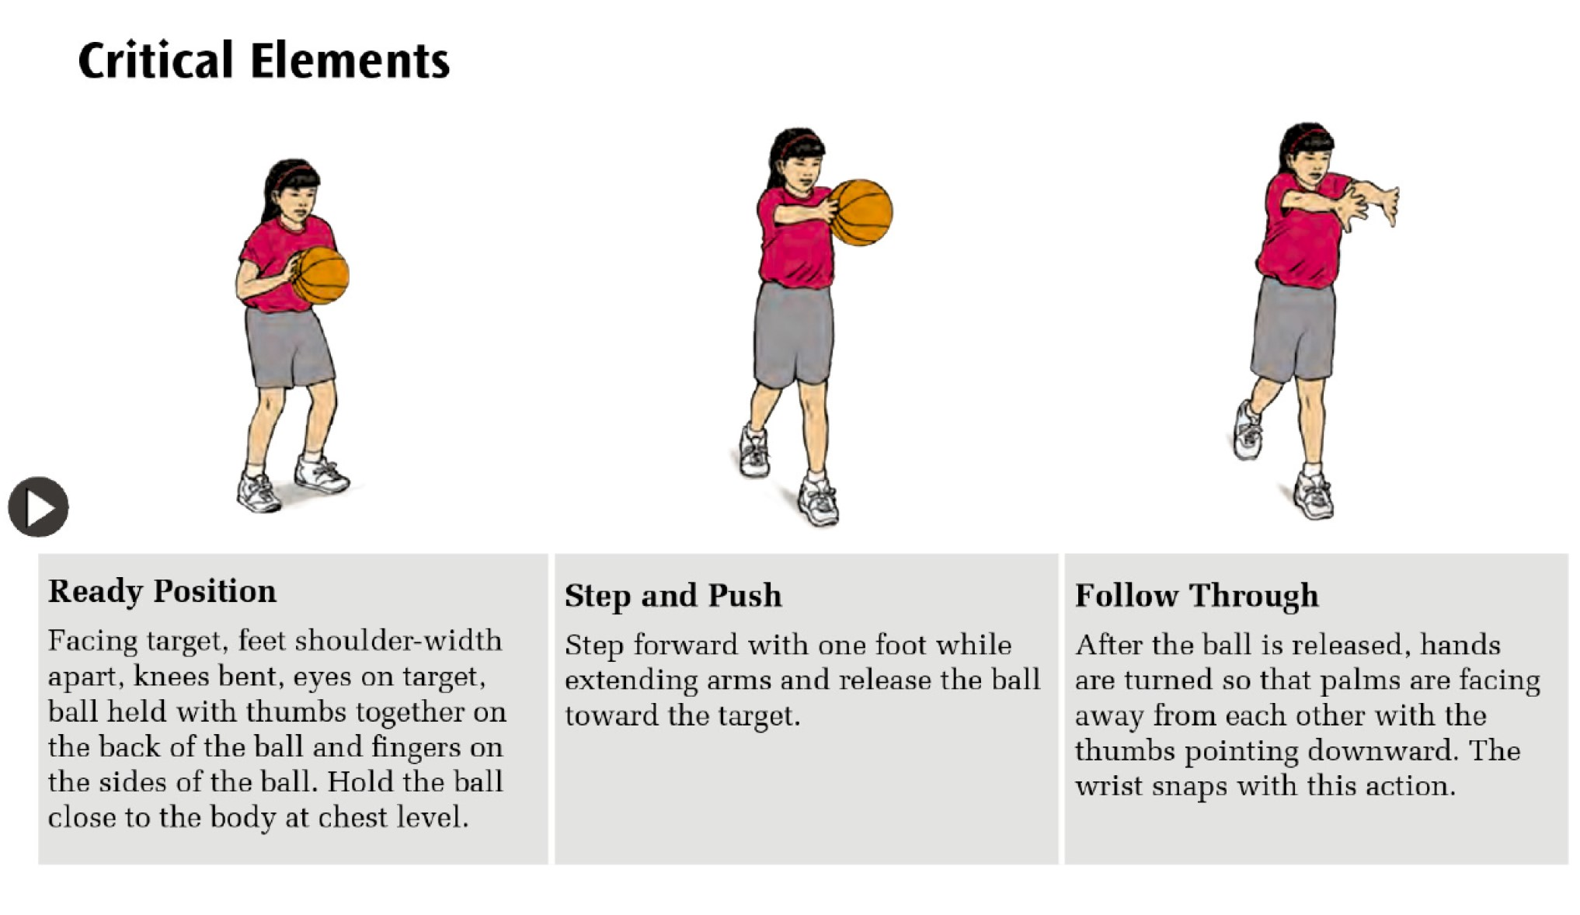
A chest pass is a manipulative skill predominantly used in games like basketball, where accuracy and control are essential. It involves a pushing-out action, using both hands to propel the ball forward towards a partner or target. The chest pass develops arm strength, coordination, and timing, which are important for team sports and real-world tasks involving throwing.

Technical Explanation of a Chest Pass
The chest pass involves three key phases:
- Ready Position
  - Stand facing the target with feet shoulder-width apart.
  - Knees are slightly bent for balance.
  - Hold the ball close to your chest with thumbs pointing towards each other and fingers on the back of the ball.
  - Cue: “Thumbs together, ball at chest!”
- Step and Push
  - Step forward with one foot for balance and power.
  - Extend both arms forward, pushing the ball toward the target with a smooth motion.
  - Release the ball at chest level.
  - Cue: “Step forward, push the ball!”
- Follow Through
  - After releasing the ball, hands turn so that palms face outwards and thumbs point down.
  - Arms extend fully for a proper follow-through.
  - Cue: “Turn the hands, finish strong!”

Pedagogical Strategies for Teaching the Chest Pass

Explicit Instruction (I Do, We Do, You Do)
- I Do: Demonstrate the chest pass, breaking it down step-by-step: Ready Position → Step and Push → Follow Through.
- We Do: Guide students in pairs or small groups to practice together. Use verbal and physical prompts.
- You Do: Allow independent practice with feedback.

Visual Aids and Demonstrations
- Use pictures, task cards, or diagrams to show each phase of the pass.

- Video modelling: Share short videos demonstrating correct technique.

Task Analysis
Break the skill into smaller, manageable parts:
- Ready Position → 2. Step Forward → 3. Push the Ball → 4. Follow Through

Adaptations (TREE Framework)
- Teaching Methods: Use simple instructions with cues like “Step, push, follow through!”
- Rules: Use lighter-weight balls or shorter distances for beginners.
- Equipment: Use targets (e.g., cones or hoops) to aim at for focus and motivation.
- Environment: Conduct practice in open spaces with minimal distractions.
Student Profile | Adaptation
Students with low motor skills | Use lighter balls and allow smaller steps with shorter throws.
Students with ASD (sensory needs) | Use verbal cues and physical demonstrations. Minimize distractions.
Students with high energy | Introduce targets or games to add purpose to the throw (e.g., aiming for hoops).

Suggested Activities for Teaching the Chest Pass
- Ready Position Practice
  - Face the target and hold the ball close to the chest with thumbs together.
- Step and Push
  - Practice stepping forward while extending the arms and releasing the ball.
- Target Practice
  - Place targets (e.g. hoops) for students to aim at. Adjust distances to suit abilities.
- Partner Passing
  - Pass the ball back and forth with a partner while focusing on the correct technique.
- Follow Through Challenge
  - Emphasize turning the hands after release to reinforce the follow-through phase.

Key Teaching Points for the Chest Pass
- Use simple, clear instructions and verbal cues like “Step, push, follow through!”
- Demonstrate the skill step-by-step, emphasizing the ready position, arm extension, and follow-through.
- Adapt activities using lighter balls, closer targets, or modified movements.
- Reinforce correct technique through positive feedback: “Great job keeping your thumbs together!”
- Keep the activity engaging with targets, games, or partner challenges.

Why is the Chest Pass Important?
Chest passes develop hand-eye coordination, arm strength, and teamwork skills. For SEN students, learning to pass a ball can support their ability to carry and hand over objects safely, such as groceries, books, or toys. It also encourages participation in modified team games or hobbies like basketball drills, promoting social interaction and physical play.

What is Underhand Throw?
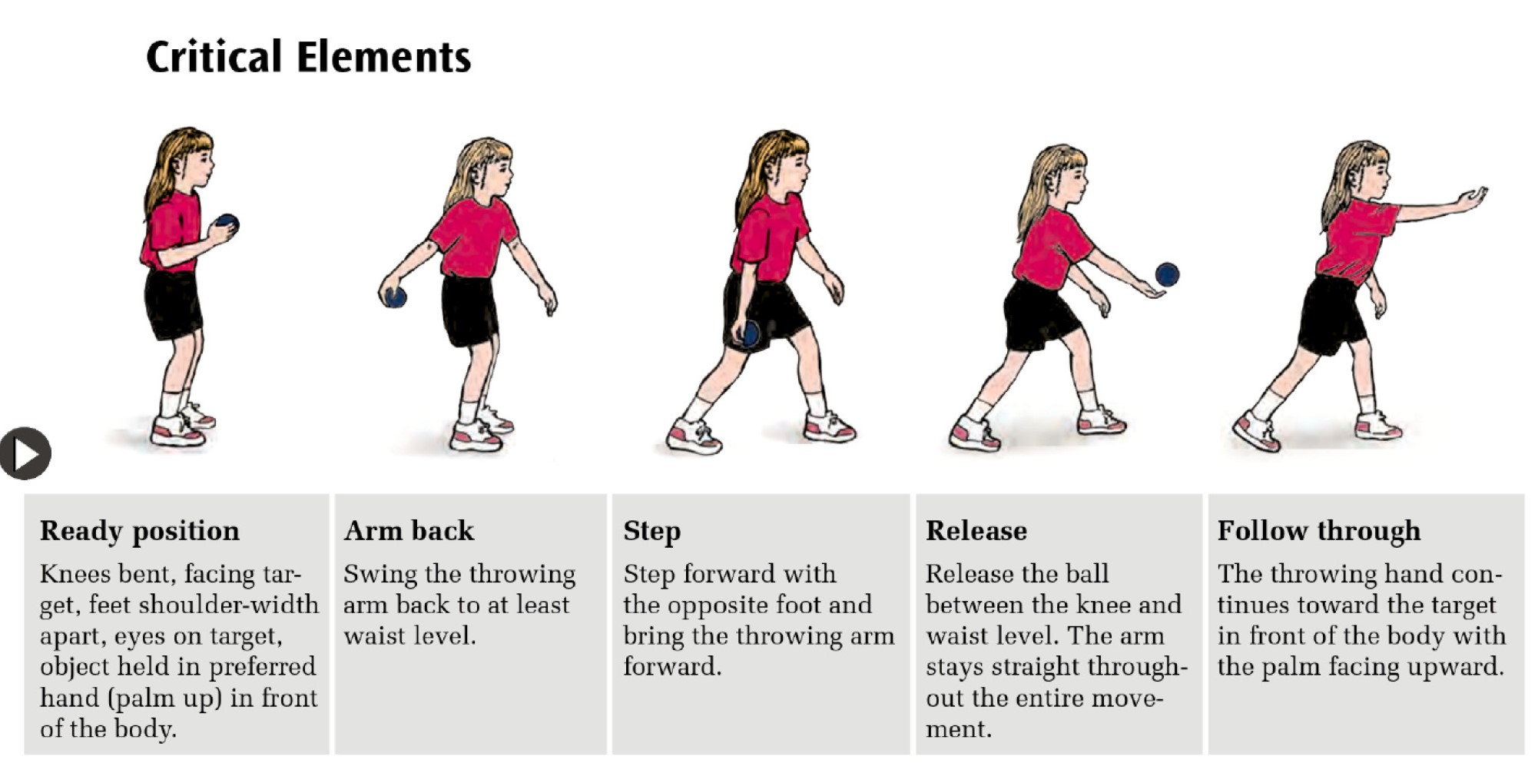
The underhand throw is a fundamental manipulative skill where an object (e.g., ball or beanbag) is thrown underarm using a smooth and controlled motion. It is commonly used in games like modified softball, underhand badminton serves, and volleyball serves. This skill helps develop coordination, balance, and accuracy.

Technical Explanation of Underhand Throw
The underhand throw involves four key phases:
- Ready Position:
  - Stand facing the target, feet shoulder-width apart.
  - Bend knees slightly, hold the ball with the dominant hand in front of the body (palm up).
  - Eyes focus on the target.
- Arm Back:
  - Swing the throwing arm back to at least waist level while maintaining a stable stance.
- Step:
  - Step forward with the opposite foot (non-dominant foot) towards the target to generate momentum.
- Release and Follow-Through:
  - Swing the dominant arm forward, releasing the ball at waist level or between the knee and waist.
  - Keep the arm straight throughout the movement.
  - Follow through by continuing the arm swing upwards and forward, finishing above the waist.

Pedagogical Strategies for Teaching Underhand Throw
- Explicit Instruction (I Do, We Do, You Do):
  - I Do: Demonstrate the movement step-by-step using clear cues like “Swing back, step, throw, and follow-through.”
  - We Do: Guide students in pairs or small groups to practice under supervision. Use prompts or physical guidance if necessary.
  - You Do: Allow independent practice while providing constructive feedback.
- Visual Aids and Demonstrations:
  - Use task cards, diagrams, or videos to illustrate the phases of the underhand throw.

  - Highlight the cues: “Swing back → Step → Throw → Follow through.”
- Task Analysis:
  - Break the throw into smaller, manageable steps:
    - Face target → 2. Swing arm back → 3. Step forward → 4. Release ball → 5. Follow through.
- Adaptations (TREE Framework):
  - Teaching Methods: Use verbal cues, visuals, and modeling to teach step-by-step.
  - Rules: Allow shorter distances or rolling for beginners before progressing to the full throw.
  - Equipment: Use lightweight balls, beanbags, or targets with varying heights.
  - Environment: Minimize distractions, and create clear pathways or zones for practice.

Suggested Activities for Teaching Underhand Throw
- Stationary Throw:
  - Start in ready position. Swing the arm back, step forward, and release towards a close target.
- Target Throw:
  - Place cones or hoops at different distances. Students aim and throw the ball into the target.
- Partner Throw:
  - Pair students to practice throwing the ball back and forth at a close distance. Gradually increase the distance.
- Beanbag Toss Game:
  - Students throw beanbags into colored hoops or buckets placed at various distances.
- Obstacle Throw:
  - Throw the ball under a low rope or arch, focusing on a smooth release and follow-through.

Key Teaching Points for Underhand Throw
- Use clear, simple cues like “Swing back, step, throw, and follow through.”
- Demonstrate step-by-step, focusing on the ready position, arm swing, step, and follow-through.
- Break the throw into smaller parts for easier learning.
- Adapt activities based on students’ abilities using visuals, lightweight equipment, or shorter distances.
- Provide positive reinforcement to encourage confidence and accuracy.

Why is Underhand Throw Important?
The underhand throw builds coordination, accuracy, and control of arm movements. For SEN students, this skill can help them perform daily tasks like tossing laundry into a basket, throwing lightweight objects into bins, or playing catch with family and friends. Underhand throws can also be applied to hobbies like softball, bowling, or simple target games, promoting enjoyment and focus.

What is Dribbling with Hands?
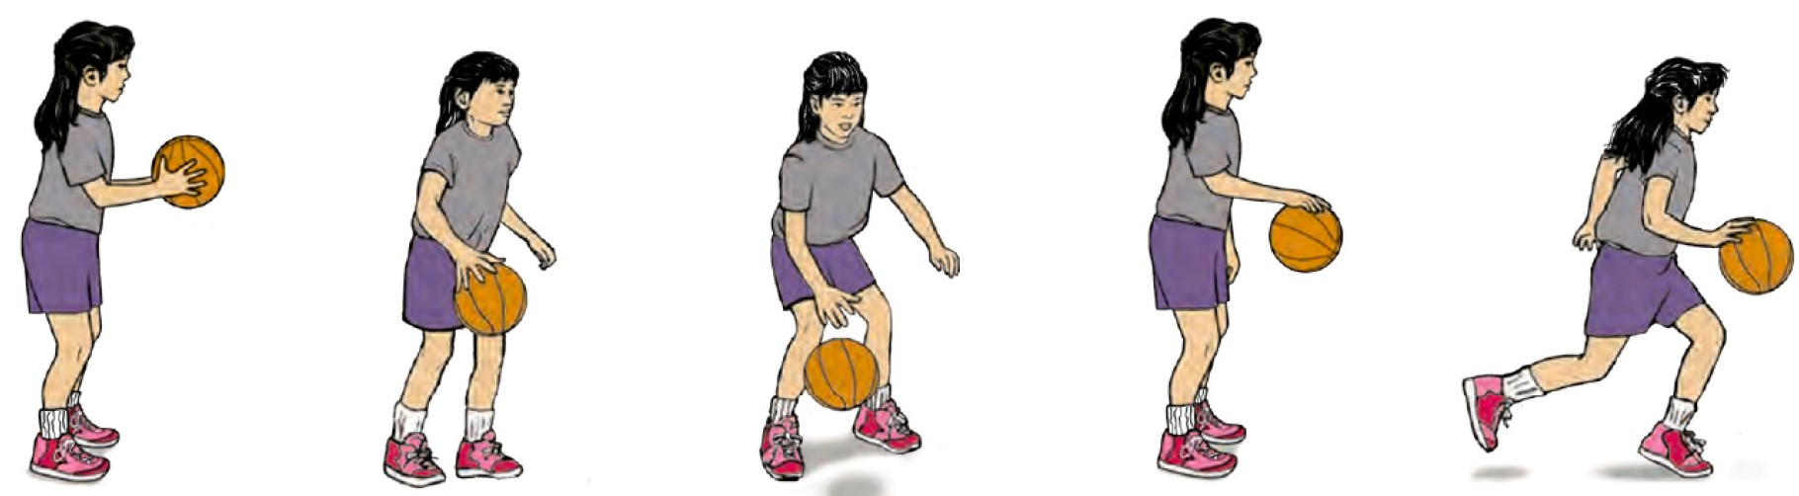
Dribbling with the hands, as commonly used in basketball, involves bouncing the ball repeatedly while moving. It requires control, rhythm, balance, and spatial awareness. Students use the pads of their fingers and thumb to push the ball down gently while maintaining possession.
Dribbling begins with stationary practice to develop proper technique before progressing to controlled movement. To ensure accuracy, avoid a "slapping" action with the palm or wrist. Instead, encourage students to use a pushing motion for better control and consistency.

Technical Explanation of Dribbling
- Ready Position
Knees are bent, and the foot opposite the dribbling hand is slightly forward. The ball is held in both hands in front of the body.
- Arm Motion
The dominant hand pushes the ball down at waist level or below. The wrist flexes, and the elbow extends in the direction of travel.
- Fingers
Use the pads of all four fingers and the thumb for contact (Do not use the palm). Avoid slapping by keeping the hand relaxed and cupped.
- Eyes Forward
Students’ eyes remain focused ahead rather than on the ball.
- Movement
Contact with the ball occurs slightly behind the body while moving. Use controlled bounces to keep the ball close to the body.

Pedagogical Strategies for Teaching Dribbling

1. Explicit Instruction (I Do, We Do, You Do):
- I Do: Demonstrate stationary dribbling with a focus on correct hand positioning and control.
- We Do: Guide students to bounce the ball in place with cues like "Push, don’t slap."
- You Do: Allow independent practice, starting with stationary dribbling before progressing.

2. Visual Aids and Demonstrations:
- Use pictures, task cards, or videos to show correct hand placement and controlled dribbling.
- Demonstrate the difference between a pushing motion (correct) and a slapping motion (incorrect).

3. Task Analysis (Break dribbling into smaller, manageable steps):

- Ready Position → 2. Push the ball down → 3. Catch and control → 4. Look up → 5. Add movement.

4. Adaptations (TREE Framework):
- Teaching Methods: Use simple verbal cues such as "Push, bounce, control."
- Rules: Allow stationary dribbling first, then gradually introduce movement.
- Equipment: Use lightweight or smaller balls to help with control.
- Environment: Provide clear, open spaces with minimal distractions.
Student Profile | Adaptation
Students with low motor skills | Start with stationary bouncing using a lightweight or soft ball at waist level.
Students with ASD (sensory challenges) | Use rhythmic verbal cues ("Push, push") and minimize sensory distractions.
Students with high energy | Incorporate movement-based activities, such as dribbling along pathways.

Suggested Activities for Teaching Dribbling
- Stationary Bouncing with Hands
  - Students practise bouncing the ball on the spot.
  - Cue: "Push the ball gently. Keep your eyes up."
- Controlled Movement Drills
  - Students dribble the ball while walking in a straight line.
  - Use markers to guide their path.
- Dribbling Relay Race
  - Students dribble the ball from one cone to another and return.
  - Adapt: Use walking speed for beginners; increase speed gradually.
- Dribbling Circle
  - Form a circle. Students dribble on the spot while maintaining focus and control.
- Obstacle Dribbling
  - Set up a path with cones for students to dribble around.
  - Simplify by allowing students to hold the ball briefly if they lose control.

Key Teaching Points for Dribbling
- Use simple, clear instructions and rhythmic cues like “Push, bounce, push.”
- Start with stationary dribbling to focus on hand position and control.
- Progress to controlled movement as students gain confidence.
- Emphasize the pushing motion using the pads of the fingers, not slapping.
- Provide positive reinforcement to celebrate small successes and build confidence.
- Adapt the activity using smaller balls or simplified rules to match students’ abilities.

Why is Dribbling Important?
Dribbling with one hand enhances hand-eye coordination, focus, and rhythm while teaching control of an object. For SEN students, it supports skills like carrying or handling objects carefully while walking, such as trays or bags. Dribbling activities can also lead to hobbies like basketball, recreational games, or bouncing exercises, fostering physical activity and social engagement.

What is Two-Hand Sidearm Striking?
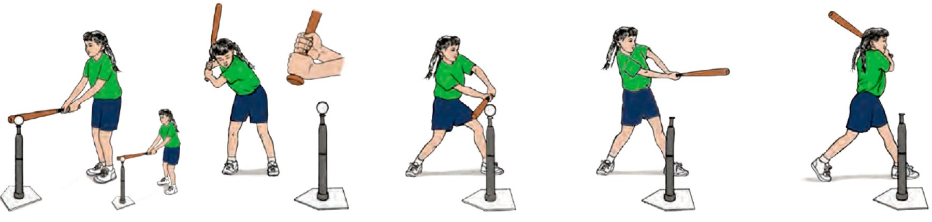
Two-hand sidearm striking is a skill where a bat, paddle, or racket is swung horizontally across the body to hit an object (e.g., a ball) placed at the side. This movement combines coordination, balance, and force to strike effectively. It builds essential motor skills for sports such as softball, tee-ball, and tennis, while promoting trunk rotation, weight transfer, and timing.

Technical Explanation of Two-Hand Sidearm Striking
The movement involves five key phases:
- Foot Placement:
  - Stand one step away from the tee or object.
  - Front foot aligns with the tee.
  - Arms are extended so the bat touches the tee.
- Ready Position:
  - Grip the bat with the dominant hand on top of the non-dominant hand.
  - Hold the bat up and behind the dominant shoulder.
  - Chin placed near the non-dominant shoulder, eyes looking at the ball.
  - Back elbow is parallel to the ground.
- Step and Swing:x
  - Step forward with the front foot.
  - Transfer weight from the back foot to the front foot.
  - Rotate hips and trunk while swinging the bat horizontally.
- Hit:
  - Arms extend fully.
  - Bat makes contact with the ball in line with the front foot.
- Follow Through:
  - Bat continues its path across the body.
  - Back shoulder rotates under the chin.
  - Both hands remain on the bat.

Pedagogical Strategies for Teaching Two-Hand Sidearm Striking
- Explicit Instruction (I Do, We Do, You Do):
  - I Do: Demonstrate the movement, focusing on the grip, swing path, and weight transfer.

  - We Do: Guide students step-by-step in small groups. Use physical prompts if needed.
  - You Do: Allow independent practice with feedback.
- Visual Aids and Demonstrations:
  - Use pictures, task cards, or videos to illustrate the correct swing sequence.
  - Highlight key points like bat position, elbow level, and follow-through.
- Task Analysis:
Break the skill into smaller steps:
  - Find proper foot placement → Grip the bat → Hold bat behind shoulder → Step and swing → Extend arms fully → Follow through.
- Adaptations (TREE Framework):
  - Teaching Methods: Simplify cues (e.g., "Step, swing, follow through") and use slower swings for beginners.
  - Rules: Allow striking a stationary ball first. Progress to moving targets later.
  - Equipment: Use lighter bats, larger balls, or paddles for easier practice.
  - Environment: Provide ample space with minimal distractions.

Student Profile | Adaptation
Students with low motor skills | Use lighter bats, larger balls, or stationary objects (e.g., a ball on a tee) for easier practice.
Students with ASD (sensory challenges) | Minimize distractions, provide clear visual cues (e.g., marked swing path), and use simplified verbal prompts.
Students with high energy or confidence | Introduce moving balls or targets and increase the striking distance gradually.

Suggested Activities for Teaching Two-Hand Sidearm Striking
- Batting Stationary Ball:
  - Use a tee to hold the ball. Focus on grip, step, and swing technique.
- Swing with Visual Targets:
  - Place cones or markers to guide the horizontal swing path.
- Step-and-Hit Practice:
  - Step forward with the front foot while swinging to develop weight transfer.
- Modified Batting Games:
  - Set up stations where students hit balls toward targets. Use large, soft balls for beginners.
- Progression to Rolling Ball:
  - Introduce slow, rolling balls for students to hit once ready.

Key Teaching Points for Two-Hand Sidearm Striking
- Use simple, clear cues like “Step, swing, hit, and follow through.”
- Focus on the bat grip, foot placement, and flat swing path to improve accuracy.
- Provide visual and physical prompts to guide weight transfer and arm extension.
- Adapt the activity based on students’ abilities using lighter equipment and simplified movements.
- Reinforce correct follow-through to build strength, coordination, and confidence.

Why is Two-Hand Sidearm Striking Important?
Two-hand sidearm striking helps students develop coordination, trunk rotation, and balance. It builds essential motor skills for recreational activities, such as tee-ball or softball, while fostering teamwork and timing. For SEN students, mastering this skill supports daily living tasks like sweeping, pushing objects, or using tools effectively. It also encourages engagement in hobbies like striking games or modified sports, promoting participation and enjoyment in group activities.

