### **What is Leaping?**

Leaping is a **locomotor movement** where students take off from one foot and land on the opposite foot. It is an **exaggerated running motion** and a foundational movement that helps develop **coordination, balance, and strength**. Leaping is used in **sports** (e.g., basketball, hurdles), **leisure activities** (e.g., skipping games), and **daily life tasks** (e.g., stepping over obstacles).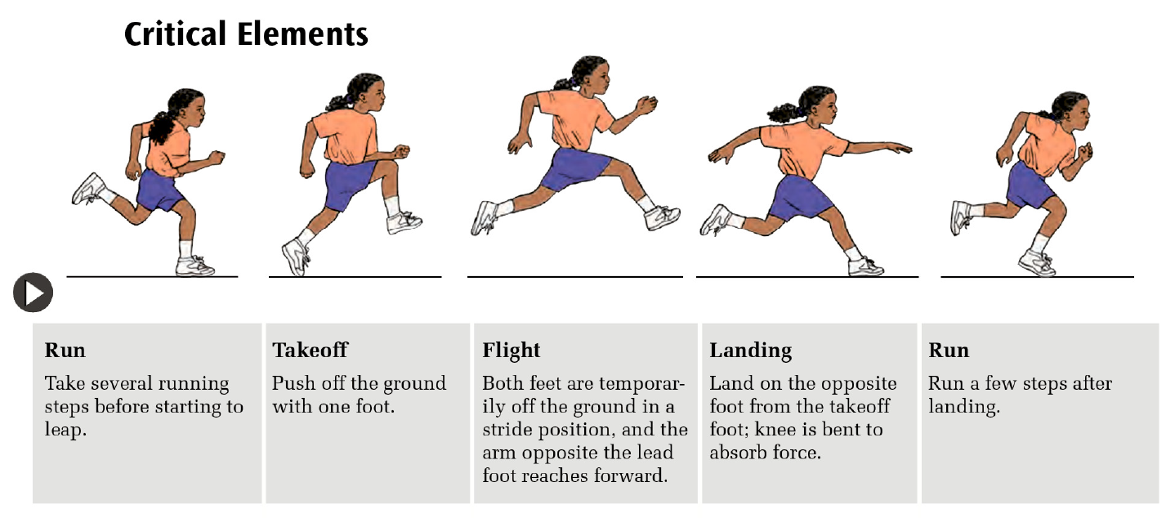

### **Technical Explanation of Leaping**

Leaping involves **four key phases**:

1. **Preparation (Run):**
   * Take small running steps to gain momentum.
   * Arms swing naturally to generate balance and rhythm.
2. **Takeoff:**
   * Push off **one foot** forcefully.
   * Swing the opposite knee and arms forward to propel the body **upward and forward**.
   * Verbal Cue: “Push and swing!”
3. **Flight:**
   * Both feet leave the ground.
   * The body fully extends as students “fly” forward.
   * Verbal Cue: “Stretch out like a superhero!”
4. **Landing:**
   * Land softly on the **opposite foot** with the knee bent to absorb impact.
   * Maintain balance with arms spread slightly.
   * Verbal Cue: “Land softly like a cat.”

### **Suggested Activities for Leaping**

1. **Stationary Takeoff and Land:**
   * From a standing position, push off one foot and land softly on the opposite foot.
   * Focus on swinging the arms and balancing on landing.
2. **Walk, Leap, and Land:**
   * Students take walking steps, then leap over a line or marker.
   * Increase the distance gradually as students gain confidence.
3. **Obstacle Leap:**
   * Use cones, hoops, or mats as “puddles” or “hurdles” for students to leap over.
   * Encourage students to shout “Leap!” as they jump to make it engaging.
4. **Leaping Challenge (Modified Game):**
   * Students leap from one marker to another, following a visual trail.
   * Use prompts: *“Push off, swing high, and land softly!”*

### **Key Teaching Points for Leaping**

1. Use **simple, clear instructions** and visual aids.
2. Demonstrate the leap step-by-step, focusing on **takeoff, flight, and landing**.
3. Provide **positive feedback**: “Well done for swinging your arms!”
4. Adapt the activity based on **students' abilities** and needs

**What is Skipping?**

Skipping is a locomotor skill that combines a **step and a hop** on the same foot, performed rhythmically and with a smooth, flowing motion. It develops **coordination, rhythm, balance**, and **motor control**, which are essential for sports, dance, and daily tasks.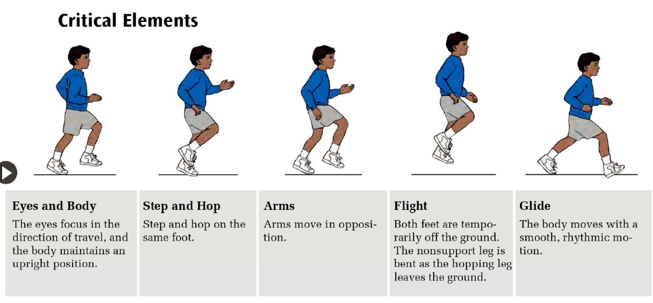

### **Technical Explanation of Skipping**

Skipping involves **five key elements**:

1. **Eyes and Body**:
   * Eyes focus on the direction of travel.
   * Body remains upright with a slight forward lean.
2. **Step and Hop**:
   * Step forward on one foot, then hop on the same foot.
   * Repeat the movement with the other foot.
3. **Arms**:
   * Arms swing in opposition to the legs for balance and momentum.
   * Cue: “Step with the left, swing the right arm!”
4. **Flight**:
   * Both feet leave the ground during the hop.
   * The nonsupport leg bends as the hopping leg pushes off.
5. **Glide**:
   * The body moves smoothly and rhythmically in a forward motion.

### 

### 

### **Suggested Activities for Teaching Skipping**

1. **Step-and-Hop Practice**:
   * Start with walking steps: *Step → Pause → Hop.*
   * Gradually reduce pauses to build rhythm and coordination.
2. **Skipping with Rhythmic Cues**:
   * Use **clapping**, tambourines, or verbal cues like *“Step-hop, step-hop”* to teach rhythm.
3. **Skipping Pathway**:
   * Create trails using **markers or hoops** for students to follow.
   * Simplify: Step through markers first, then introduce hopping.
4. **Skipping Games**:
   * **Follow the Leader**: Teachers or peers demonstrate skipping patterns, and students follow.
   * **Beanbag Skipping**: Students skip to pick up beanbags placed along a pathway.
   * **Skipping to Music**: Play a song with a steady beat to encourage rhythmic skipping.
5. **Building Up to Skipping**:
   * Practice **hopping on one foot** to develop balance and coordination.
   * Use small hurdles or markers to introduce the **step-hop** motion.
   * Start with **galloping**, then transition to skipping to establish rhythm.

### **Key Teaching Points for Skipping**

1. Use **simple, consistent instructions** and rhythmic cues like *“Step-hop, step-hop.”*
2. Demonstrate skipping step-by-step, focusing on the **step, hop, and arm swing** phases.
3. Adapt the activity using **visuals**, simplified movements, or physical prompts.
4. Provide **positive reinforcement** to celebrate progress and build confidence.
5. Make learning fun by incorporating **music, games**, and engaging visuals.

### **What is Sliding?**

Sliding is a locomotor skill that involves moving sideways in a step-close pattern. One foot leads the action, followed by the other foot quickly closing to meet it. This skill develops **rhythm, balance, and coordination** and is essential for activities that require quick lateral movements, such as sports, games, and real-life tasks.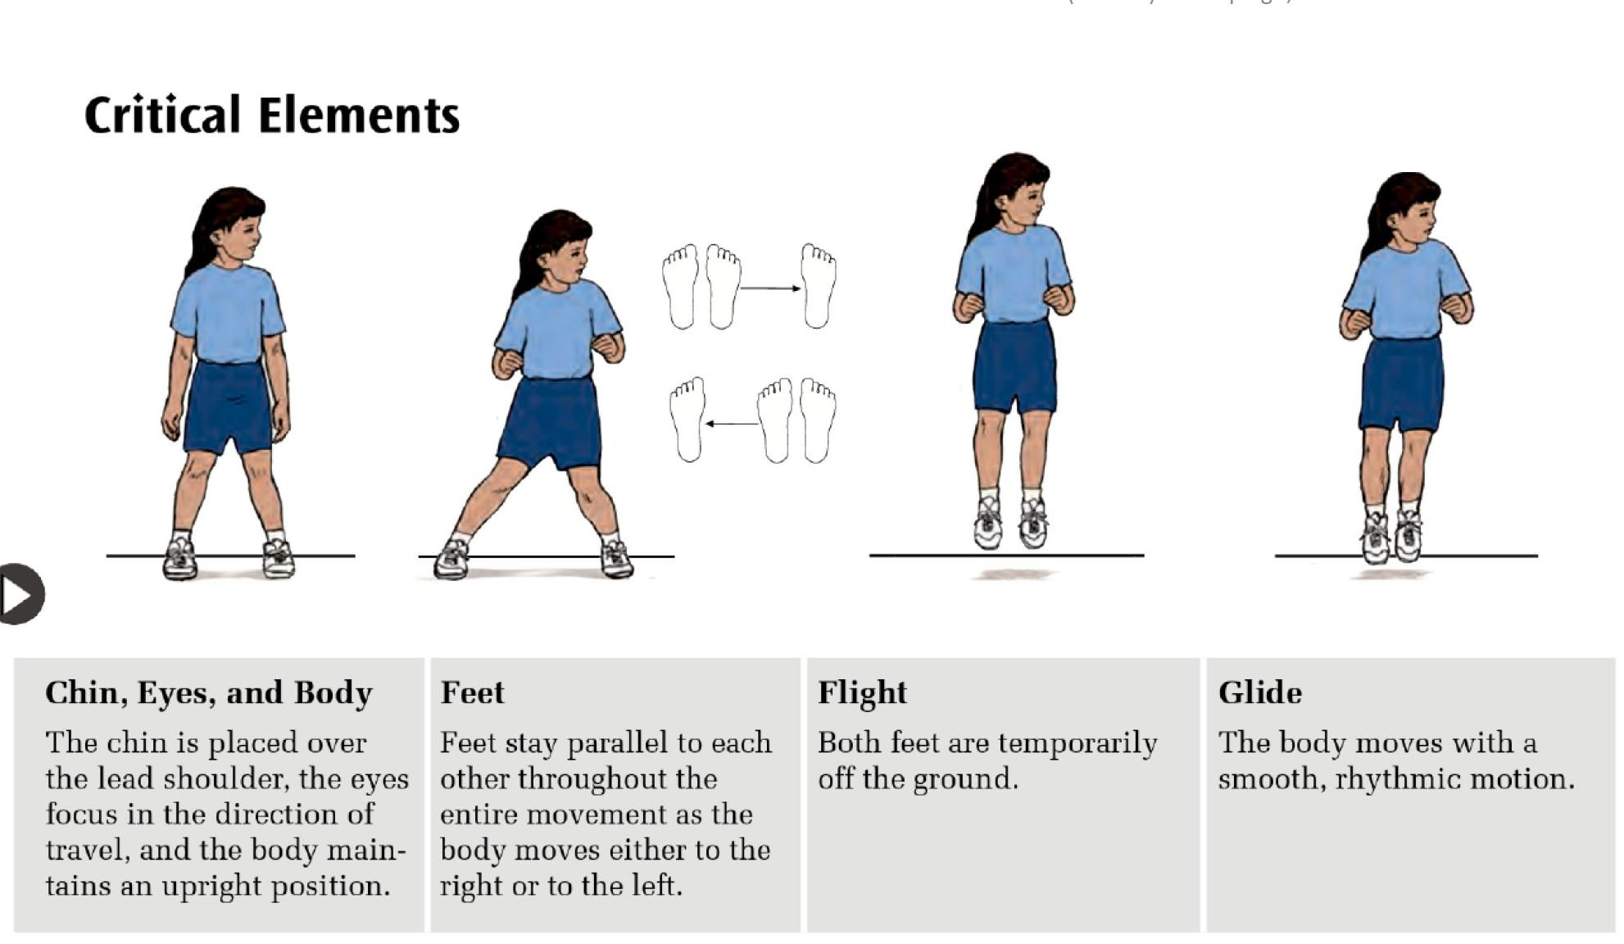

### **Technical Explanation of Sliding**

Sliding involves **four key elements**:

1. **Chin, Eyes, and Body**
   * Chin is placed over the lead shoulder.
   * Eyes focus in the direction of movement.
   * Body stays upright with a slight lean forward.
2. **Feet**
   * Feet remain parallel throughout the movement.
   * Lead foot steps sideways while the trailing foot quickly “closes the gap.”
3. **Flight**
   * Both feet temporarily leave the ground as the trailing foot moves toward the lead foot.
4. **Glide**
   * The movement is smooth and rhythmical, with consistent step-close rhythm: “step-close, step-close.”

### 

### 

### 

### 

### **Suggested Activities for Teaching Sliding**

1. **Step-Close Practice:**
   * Start with slow steps: “Step-close, pause.”
   * Gradually reduce pauses to build rhythm and smooth motion.
2. **Sliding Pathway:**
   * Place markers or cones in a straight line. Students slide along the line.
   * Simplify: Use shorter distances and larger markers for students who need support.
3. **Mirror Sliding:**
   * In pairs, one student leads the slide movement while the other mirrors.
   * Encourage switching roles after a few rounds.
4. **Sliding Challenge:**
   * Students slide to pick up beanbags or other small objects placed along a pathway.
5. **Sliding to Music:**
   * Play music with a steady beat and have students slide to the rhythm.

### **Key Teaching Points for Sliding**

1. Use **simple, consistent instructions** like “Step-close, step-close” to guide students.
2. Demonstrate sliding step-by-step, focusing on the **step**, **close**, and smooth rhythm.
3. Adapt the activity for different abilities using visuals, smaller distances, and rhythmic cues.
4. Provide **positive reinforcement** to build confidence and celebrate effort.
5. Make the activity engaging with games, music, or visuals to encourage participation.

**What is Pivoting?**

Pivoting is a **non-locomotor** skill where a student rotates their body around a fixed point, typically one foot, while the other foot steps in a new direction. It involves balance, coordination, and control. Pivoting is crucial for sports like basketball, netball, and dance, as well as daily movements requiring a change in direction.

### **Technical Explanation of Pivoting**

Pivoting involves **four key elements**:

1. **Body and Eyes**
   * Eyes look in the direction of the pivot.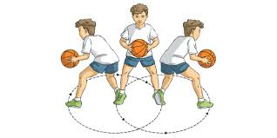
   * Body remains upright and controlled with the head aligned over the shoulders.
2. **Pivot Foot**
   * One foot stays planted on the ground as the **pivot point**.
   * The weight is placed on the ball of the pivot foot for balance.
3. **Step and Rotate**
   * The non-pivot foot steps in the desired direction.
   * The body rotates smoothly around the pivot foot.
4. **Arms for Balance**
   * Arms extend naturally to assist with balance and control during the movement.

| **Movement** | **Definition** | **Example** |
| --- | --- | --- |
| Pivot | Rotating around a fixed point (usually one foot), while the other foot steps. | Pivoting to pass a ball in basketball. |
| Turn | The whole body moves to face a new direction; the base of support may move. | Turning to face a new partner in dance. |
| Twist | One body part turns opposite to another body part or a fixed base. | Twisting the torso while seated to look back. |

### **Suggested Activities for Teaching Pivoting**

1. **Pivot Around a Marker**
   * Place a cone or marker on the floor. Students practice planting one foot next to the marker and pivoting around it while keeping balance.
2. **Ball Passing Pivot**
   * In pairs, students pivot to pass a ball to a partner. Focus on using a planted pivot foot and smooth body rotation.
3. **Pivot and Turn Relay**
   * Students take turns running to a marker, planting their pivot foot, and rotating to return in the opposite direction.
4. **Mirror the Pivot**
   * Teachers demonstrate a pivot movement while students mimic the action.
5. **Pivoting in Games**
   * Incorporate pivoting into games such as basketball drills, netball passing, or dance

### **Key Teaching Points for Pivoting**

1. Use **simple, clear instructions** like “Plant, step, turn” to guide the movement.
2. Demonstrate pivoting step-by-step, focusing on the pivot foot, smooth body rotation, and balance.
3. Adapt the activity for students' abilities by starting with smaller angles or add floor markers.
4. Reinforce **balance and control**, reminding students to keep their weight on the ball of the pivot foot.
5. Make learning fun by incorporating pivoting into games, challenges, or rhythmic activities.

### **What is Balance?**

Balance is the ability to **hold a position still** while staying stable. It builds control, strength, and coordination, helping students in **daily living skills** (e.g., standing still, sitting upright) and recreational activities (e.g., playing games or cycling).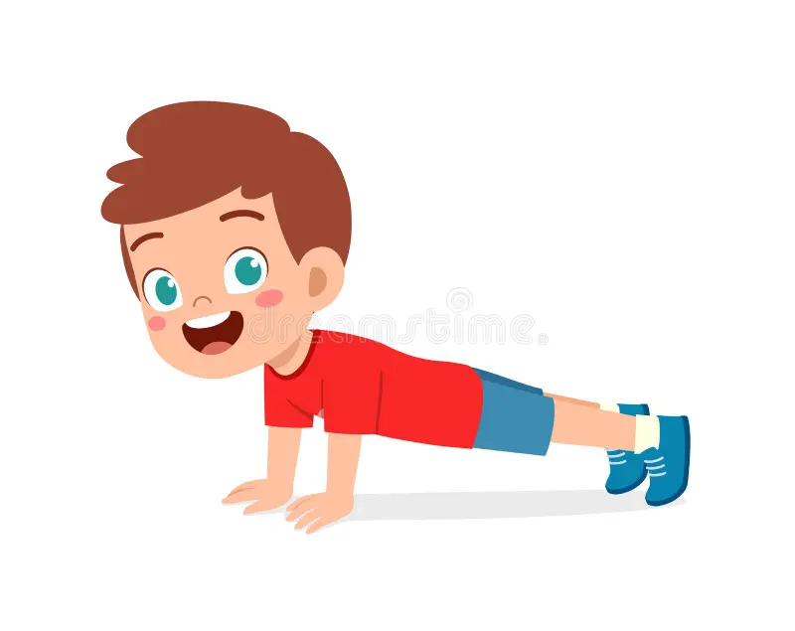

### **Technical Explanation of Balance**.

#### **Types of Balances**

1. **Point Balances**:
   * Small body parts in contact with the ground.
     + **One-Point**: Balancing on one foot.
     + **Two-Point**: Balancing on two feet or hands (e.g., plank).
     + **Three-Point**: Two hands and one foot.
     + **Four-Point**: Both hands and feet.
2. **Surface Balances**:
   * Larger areas of contact for stability.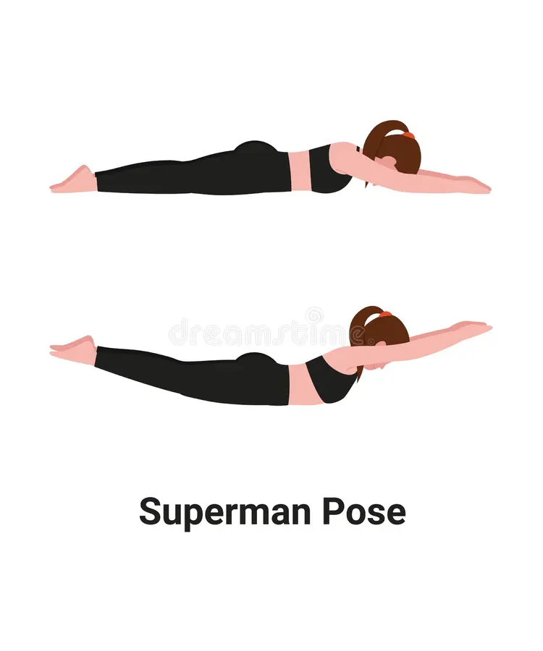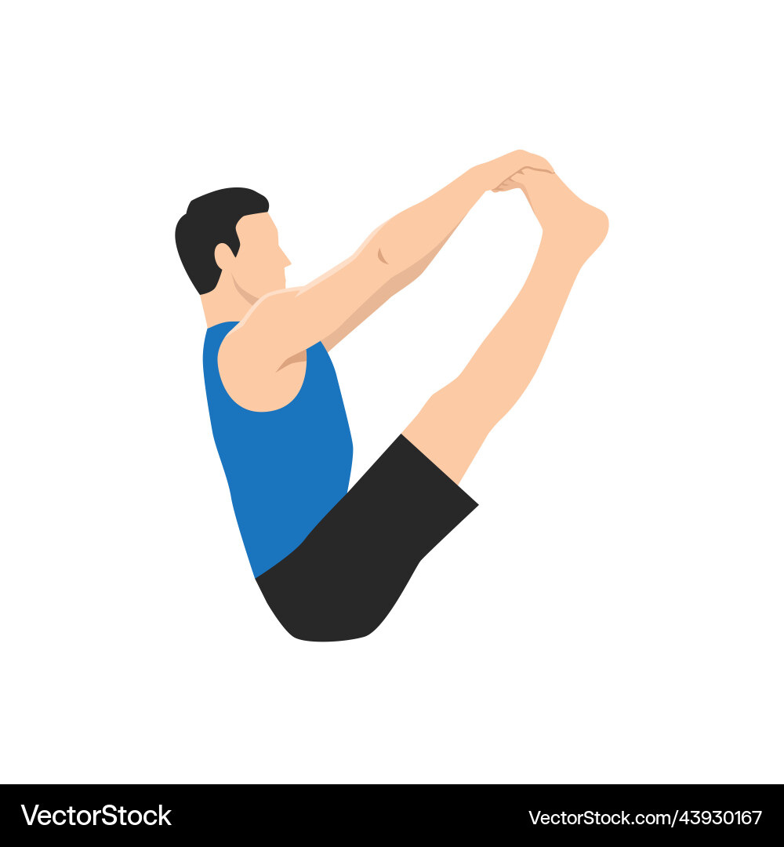
     + **Stomach**: Superman pose.
     + **Back**: Dead bug position.
     + **Seated**: V-sit position.

### 

### 

### 

### 

### **Suggested Activities for Teaching Balance**

1. **One-Point Balance**:
   * Balance on one foot with arms out. Simplify with wall or partner support.
2. **Surface Balance Challenge**:
   * **Stomach Balance**: Lift arms and legs (Superman).
   * **Back Balance**: Arms and legs lifted in a “dead bug” pose.
3. **Balancing Pathway**:
   * Balance on one foot or hold a position at markers along a path.
4. **Statue Freeze Game**:
   * Play music; students freeze in a balance position when it stops.
5. **Partner Balances**:
   * Students hold hands and balance together (e.g., one foot lifted).

### **Key Teaching Points for Balance**

1. Use **simple instructions** like “Freeze,” “Hold still,” or “Balance like a statue.”
2. Demonstrate balance positions step-by-step and provide visual examples.
3. Start with **surface balances** for greater stability, then progress to smaller points of contact (e.g., one foot).
4. Encourage students to focus on a **fixed point** for balance (e.g., a spot on the floor).
5. Provide **positive reinforcement** for effort and progress (e.g., “Good job holding still!”).

## **What is a Chest Pass?**

A **chest pass** is a manipulative skill predominantly used in games like basketball, where accuracy and control are essential. It involves a pushing-out action, using both hands to propel the ball forward towards a partner or target. The chest pass develops arm strength, coordination, and timing, which are important for team sports and real-world tasks involving throwing.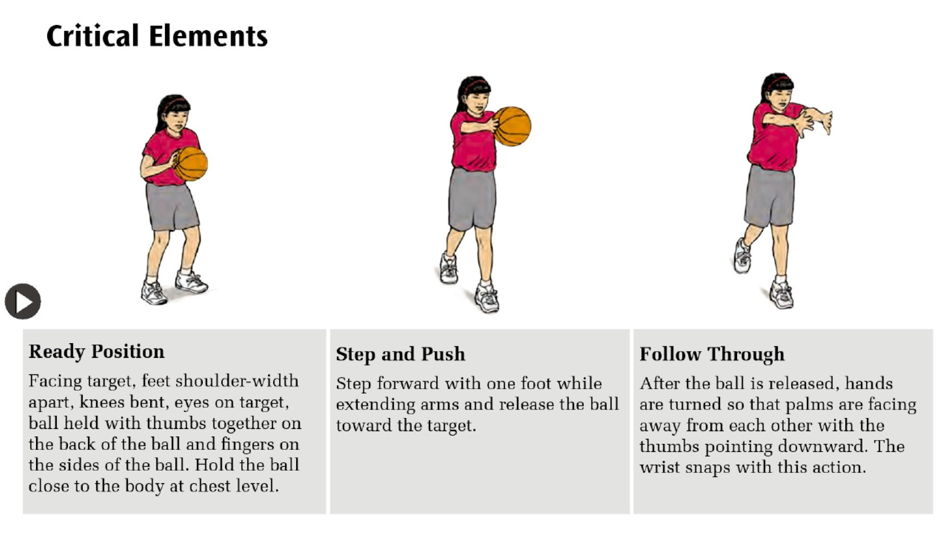

## **Technical Explanation of a Chest Pass**

The chest pass involves three key phases:

1. **Ready Position**
   * Stand facing the target with feet shoulder-width apart.
   * Knees are slightly bent for balance.
   * Hold the ball close to your chest with thumbs pointing towards each other and fingers on the back of the ball.
   * Cue: “Thumbs together, ball at chest!”
2. **Step and Push**
   * Step forward with one foot for balance and power.
   * Extend both arms forward, pushing the ball toward the target with a smooth motion.
   * Release the ball at chest level.
   * Cue: “Step forward, push the ball!”
3. **Follow Through**
   * After releasing the ball, hands turn so that palms face outwards and thumbs point down.
   * Arms extend fully for a proper follow-through.
   * Cue: “Turn the hands, finish strong!”

## 

## 

## **Suggested Activities for Teaching the Chest Pass**

1. **Ready Position Practice**
   * Face the target and hold the ball close to the chest with thumbs together.
2. **Step and Push**
   * Practice stepping forward while extending the arms and releasing the ball.
3. **Target Practice**
   * Place targets (e.g. hoops) for students to aim at. Adjust distances to suit abilities.
4. **Partner Passing**
   * Pass the ball back and forth with a partner while focusing on the correct technique.
5. **Follow Through Challenge**
   * Emphasize turning the hands after release to reinforce the follow-through phase.

## **Key Teaching Points for the Chest Pass**

1. Use simple, clear instructions and verbal cues like “Step, push, follow through!”
2. Demonstrate the skill step-by-step, emphasizing the ready position, arm extension, and follow-through.
3. Adapt activities using lighter balls, closer targets, or modified movements.
4. Reinforce correct technique through positive feedback: “Great job keeping your thumbs together!”
5. Keep the activity engaging with targets, games, or partner challenges.

### 

### **What is Underhand Throw?**

The underhand throw is a fundamental manipulative skill where an object (e.g., ball or beanbag) is thrown underarm using a smooth and controlled motion. It is commonly used in games like modified softball, underhand badminton serves, and volleyball serves. This skill helps develop coordination, balance, and accuracy.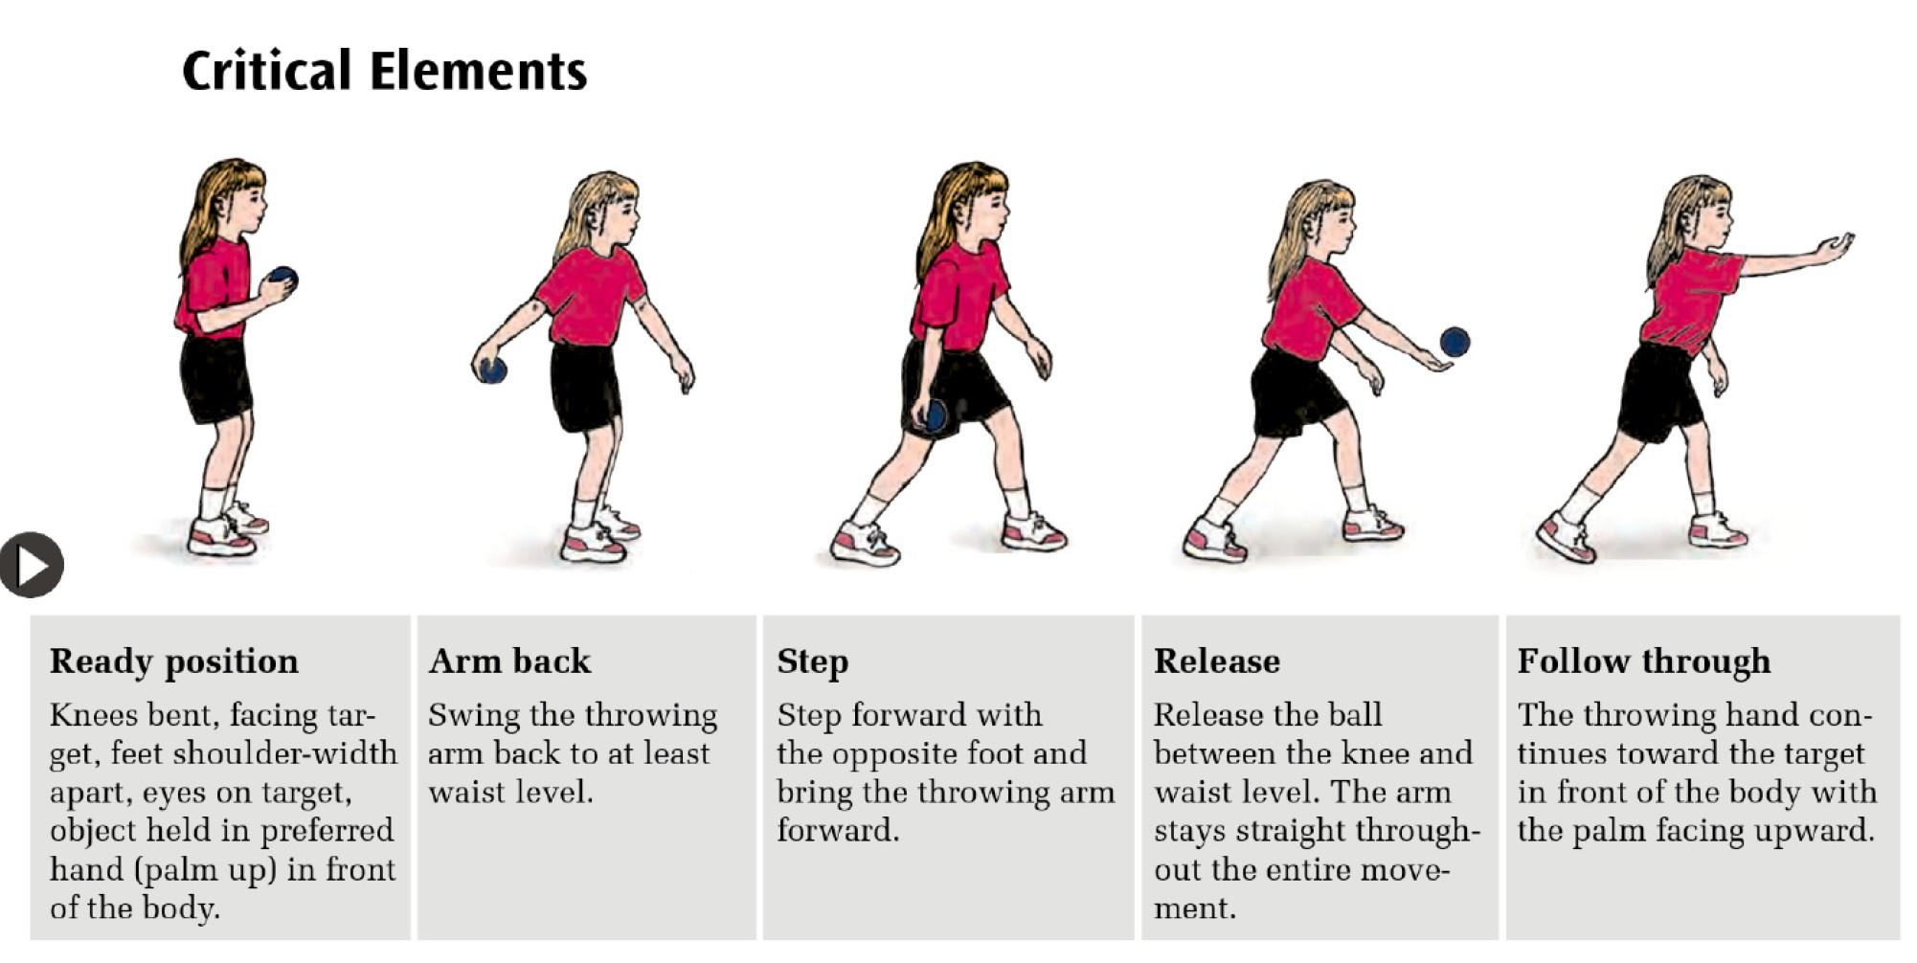

### **Technical Explanation of Underhand Throw**

The underhand throw involves four key phases:

1. **Ready Position:**
   * Stand facing the target, feet shoulder-width apart.
   * Bend knees slightly, hold the ball with the dominant hand in front of the body (palm up).
   * Eyes focus on the target.
2. **Arm Back:**
   * Swing the throwing arm back to at least waist level while maintaining a stable stance.
3. **Step:**
   * Step forward with the opposite foot (non-dominant foot) towards the target to generate momentum.
4. **Release and Follow-Through:**
   * Swing the dominant arm forward, releasing the ball at waist level or between the knee and waist.
   * Keep the arm straight throughout the movement.
   * Follow through by continuing the arm swing upwards and forward, finishing above the waist.

## 

## 

## **Suggested Activities for Teaching Underhand Throw**

1. **Stationary Throw:**
   * Start in ready position. Swing the arm back, step forward, and release towards a close target.
2. **Target Throw:**
   * Place cones or hoops at different distances. Students aim and throw the ball into the target.
3. **Partner Throw:**
   * Pair students to practice throwing the ball back and forth at a close distance. Gradually increase the distance.
4. **Beanbag Toss Game:**
   * Students throw beanbags into colored hoops or buckets placed at various distances.
5. **Obstacle Throw:**
   * Throw the ball under a low rope or arch, focusing on a smooth release and follow-through.

### **Key Teaching Points for Underhand Throw**

1. Use **clear, simple cues** like “Swing back, step, throw, and follow through.”
2. Demonstrate step-by-step, focusing on the **ready position, arm swing, step, and follow-through**.
3. Break the throw into smaller parts for easier learning.
4. Adapt activities based on students’ abilities using visuals, lightweight equipment, or shorter distances.
5. Provide **positive reinforcement** to encourage confidence and accuracy.

### **What is Dribbling with Hands?**

Dribbling with the hands, as commonly used in basketball, involves bouncing the ball repeatedly while moving. It requires control, rhythm, balance, and spatial awareness. Students use the pads of their fingers and thumb to push the ball down gently while maintaining possession. Dribbling begins with stationary practice to develop proper technique before progressing to controlled movement. To ensure accuracy, avoid a "slapping" action with the palm or wrist. Instead, encourage students to use a pushing motion for better control and consistency.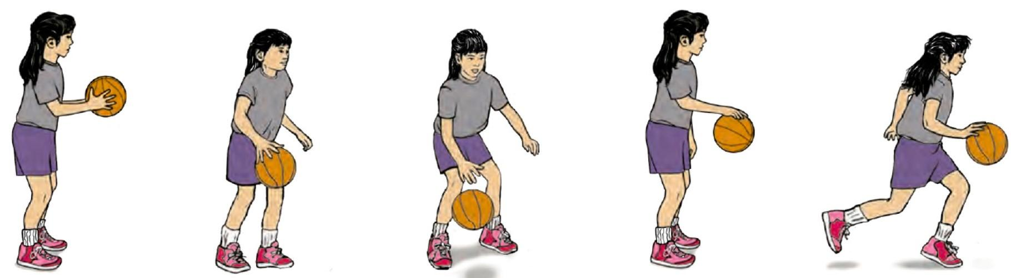

### **Technical Explanation of Dribbling**

* **Ready Position**Knees are bent, and the foot opposite the dribbling hand is slightly forward.

The ball is held in both hands in front of the body.

* **Arm Motion**The dominant hand pushes the ball down at waist level or below.

The wrist flexes, and the elbow extends in the direction of travel.

* **Fingers**Use the pads of all four fingers and the thumb for contact (Do not use the palm). Avoid slapping by keeping the hand relaxed and cupped.
* **Eyes Forward**Students’ eyes remain focused ahead rather than on the ball.
* **Movement**Contact with the ball occurs slightly behind the body while moving.

Use controlled bounces to keep the ball close to the body.

## **Suggested Activities for Teaching Dribbling**

1. **Stationary Bouncing with Hands**
   * Students practise bouncing the ball on the spot.
   * Cue: "Push the ball gently. Keep your eyes up."
2. **Controlled Movement Drills**
   * Students dribble the ball **while walking** in a straight line.
   * Use markers to guide their path.
3. **Dribbling Relay Race**
   * Students dribble the ball from one cone to another and return.
   * Adapt: Use walking speed for beginners; increase speed gradually.
4. **Dribbling Circle**
   * Form a circle. Students dribble on the spot while maintaining focus and control.
5. **Obstacle Dribbling**
   * Set up a path with cones for students to dribble around.
   * Simplify by allowing students to hold the ball briefly if they lose control.

## **Key Teaching Points for Dribbling**

1. Use **simple, clear instructions** and rhythmic cues like “Push, bounce, push.”
2. Start with **stationary dribbling** to focus on hand position and control.
3. Progress to **controlled movement** as students gain confidence.
4. Emphasize the **pushing motion** using the pads of the fingers, not slapping.
5. Provide **positive reinforcement** to celebrate small successes and build confidence.
6. Adapt the activity using **smaller balls** or simplified rules to match students’ abilities.

## **What is Two-Hand Sidearm Striking?**

Two-hand sidearm striking is a skill where a bat, paddle, or racket is swung horizontally across the body to hit an object (e.g., a ball) placed at the side. This movement combines coordination, balance, and force to strike effectively. It builds essential motor skills for sports such as softball, tee-ball, and tennis, while promoting trunk rotation, weight transfer, and timing.

## **Technical Explanation of Two-Hand Sidearm Striking**

The movement involves **five key phases**: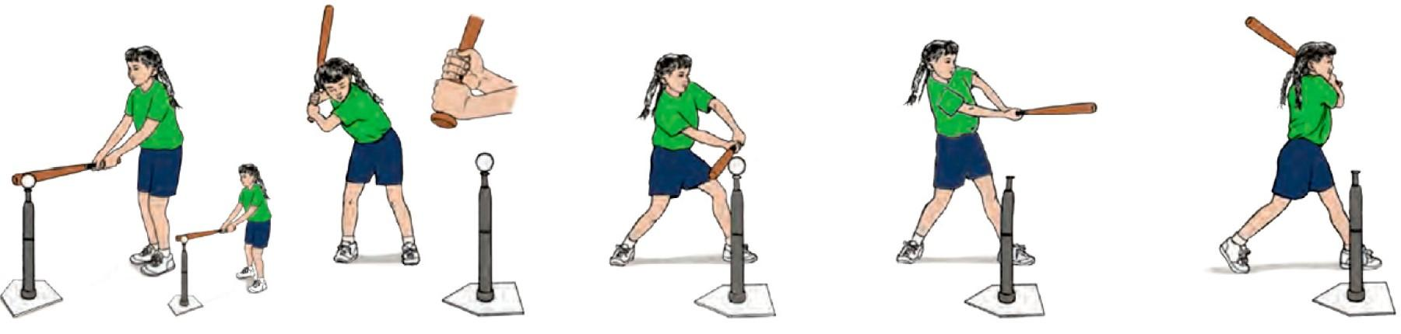

1. **Foot Placement:**
   * Stand one step away from the tee or object.
   * Front foot aligns with the tee.
   * Arms are extended so the bat touches the tee.
2. **Ready Position:**
   * Grip the bat with the **dominant hand** on top of the non-dominant hand.
   * Hold the bat **up and behind** the dominant shoulder.
   * Chin placed near the non-dominant shoulder, eyes looking at the ball.
   * Back elbow is parallel to the ground.
3. **Step and Swing:x**
   * Step forward with the **front foot**.
   * Transfer weight from the back foot to the front foot.
   * Rotate hips and trunk while swinging the bat horizontally.
4. **Hit:**
   * Arms extend fully.
   * Bat makes contact with the ball in line with the front foot.
5. **Follow Through:**
   * Bat continues its path across the body.
   * Back shoulder rotates under the chin.
   * Both hands remain on the bat.

## 

## **Suggested Activities for Teaching Two-Hand Sidearm Striking**

1. **Batting Stationary Ball:**
   * Use a tee to hold the ball. Focus on grip, step, and swing technique.
2. **Swing with Visual Targets:**
   * Place cones or markers to guide the horizontal swing path.
3. **Step-and-Hit Practice:**
   * Step forward with the front foot while swinging to develop weight transfer.
4. **Modified Batting Games:**
   * Set up stations where students hit balls toward targets. Use large, soft balls for beginners.
5. **Progression to Rolling Ball:**
   * Introduce slow, rolling balls for students to hit once ready.

## **Key Teaching Points for Two-Hand Sidearm Striking**

1. Use **simple, clear cues** like “Step, swing, hit, and follow through.”
2. Focus on the **bat grip, foot placement, and flat swing path** to improve accuracy.
3. Provide **visual and physical prompts** to guide weight transfer and arm extension.
4. Adapt the activity based on students’ abilities using lighter equipment and simplified movements.
5. Reinforce correct follow-through to build strength, coordination, and confidence.